Assignment for Module 10

The assignment for Module 10 involves problems for schema conversion. Problems 1 to 4 involve the ERD in Figure 1.
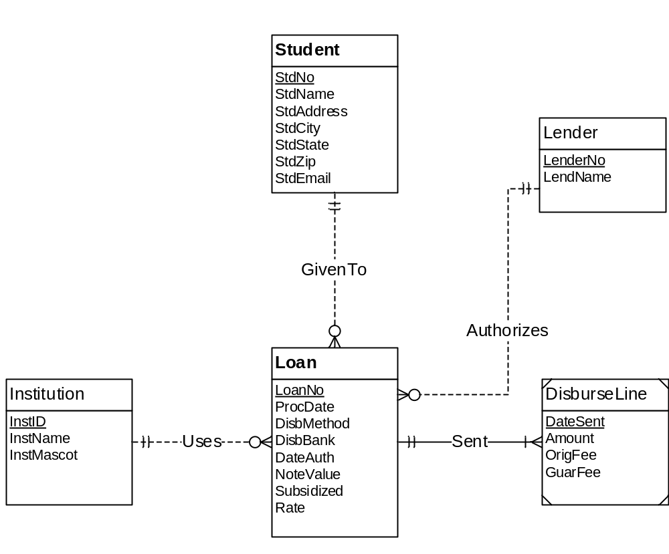
Figure 1: ERD for Problems 1 to 4
1. Requirements for Data Modeling Problems
1. For the ERD in Figure 1, you should indicate the applications of the entity type rule. For each entity type rule application, you should identify the table name, primary key, and other columns. You do not need to write CREATE TABLE statements.
Ans. The entity type rule is applied 5 times for each entity. They are --
i. Student ( StdNo, StdName, StdAddress, StdCity, StdState, StdZip, StdEmail )
ii. Institution ( InstID, InstName, InstMascot )
iii. Lender ( LenderNo, LendName )
iv. Loan ( LoanNo, ProcDate, DisbMethod, DisbBank, DateAuth, NoteValue, Subsidized, Rate)
v. DisburseLine ( DateSent, Amount, OrigFee, GuarFee )

2. For the ERD in Figure 1, you should indicate applications of the 1-M relationship rule. For each 1-M relationship rule application, you should indicate the changes to the tables you listed in problem 1 including foreign key columns and NOT NULL constraints for foreign keys if necessary.
Ans. There are 3 applications of the 1-M relationship to the Loan relation. They are the ‘Given To’, ‘Uses’ and ‘Authorizes’ relationships. The schema for Loan relation will now be--
Loan ( LoanNo, ProcDate, DisbMethod, DisbBank, DateAuth, NoteValue,
Subsidized, Rate, StdNo, InstID, LenderNo )
FOREIGN KEY (StdNo) REFERENCES Student,
FOREIGN KEY (InstID) REFERENCES Institution,
FOREIGN KEY (LenderNo) REFERENCES Lender ,
StdNo NOT NULL, InstID NOT NULL, LenderNo NOT NULL

3. For the ERD in Figure 1, you should indicate applications of the M-N relationship rule. For each M-N relationship rule application, you should list the table name, primary key, and other columns.
Ans. There are no applications of the M-N relationship rule.

4. For the ERD in Figure 1, you should indicate applications of the identifying relationship rule. For each identifying relationship rule application, you should indicate the changes to the tables you listed in problem 2.
Ans. There is one application of the Identifying relationship i.e the ‘sent’ relationship between the Loan relation and the DisburseLine which is a weak entity. DisburseLine relation will get the primary key of Loan relation (LoanNo) as a foreign key and DateSent + LoanNo together will act as the primary key for the DisburseLine relation.

DisburseLine ( DateSent, LoanNo, Amount, OrigFee, GuarFee )
FOREIGN KEY (LoanNo) REFERENCES Loan

5. Convert the ERD shown in Figure 2 into tables. List the conversion rules used and table design. For each table, you should list the primary key, foreign keys, other columns, and NOT NULL constraints for foreign keys if necessary. You do not need to write CREATE TABLE statements.
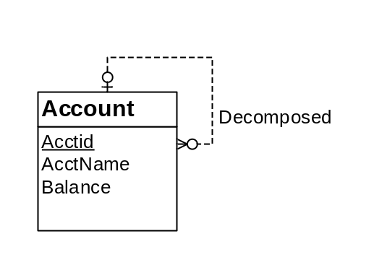
Figure 2: ERD for Conversion Problem 5
Ans. Account (AcctId, AcctName, Balance, SubAcctId)
FOREIGN KEY (SubAcctId) REFERENCES Account

Conversion Rules:
i. Use the entity type rule to convert each entity type
ii. Use the 1-M relationship rule for all relationships

6. Convert the ERD shown in Figure 3 into tables. List the conversion rules used and table design. For each table, you should list the primary key, foreign keys, other columns, and NOT NULL constraints for foreign keys if necessary. You do not need to write CREATE TABLE statements.
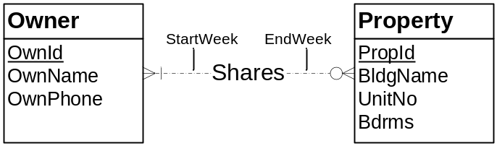
Figure 3: ERD for Conversion Problem 6
Ans. Owner ( OwnId, OwnName, OwnPhone )
Property ( PropId, BldgName, UnitNo, Bdrms )
Shares ( OwnId, PropId, StartWeek, EndWeek)
FOREIGN KEY (OwnId) REFERENCES Owner,
FOREIGN KEY (PropId) REFERENCES Property

Conversion Rules :
i. Use the entity type rule to convert each entity type
ii. Use the M-N rule to convert the shares relationship.

